Annexure3b- Complete filing

INVENTION DISCLOSURE FORM

Details of Invention for better understanding:

1.TITLE: Object Detection Camera System for Accident Prevention in Foggy Conditions
2. INTERNAL INVENTOR(S)/ STUDENT(S): All fields in this column are mandatory to be filled
A. Full name | _{Tahjud Taha Noor}
Mobile Number | 6005755263
Email (personal) | tahjudnoor@gmail.com
UID/Registration number | 12203058
Address of Internal Inventors | School Of Computer Science and Engineering  Lovely Professional University, Punjab-144411, India
Signature (Mandatory) | 

- DESCRIPTION OF THE INVENTION:
- Purpose: This system is developed to improve road safety by spotting obstacles in fog. When drivers experience low-visibility scenarios, it gives them alerts for their surroundings in real-time. The system minimizes the risk of accidents by detecting cars, pedestrians, and road obstacles. It makes driving safer by enhancing response time and decisions made while driving.
- Functionality: Using infrared imaging and LiDAR/radar sensors, the system is able to detect obstacles in foggy conditions. Various algorithms utilize real-time data and empower the vehicle to identify cars, people, and road objects with high precision. This processed information is displayed on screen, with real-time visual and audio alerts. A predictive warning system monitors proximity to objects and movement patterns to avoid collisions. The system is designed to be embedded into the vehicle electronics or work as a safety device.
- Infrared Imaging: The infrared imaging detects heat signatures of all objects so the system works well in foggy conditions where ordinary cameras fail. The ability to identify cars, pedestrians and obstacles in thick fog through thermal imaging. Infrared sensors work just as well in fog as in sunlight as they do not use visible light like cameras. The system uses artificial intelligence to process the thermal data for classification and tracking. This technology helps to detect things properly and make the drivers aware hence reducing the chances of mishaps.
- LiDAR and Radar Sensors: Devices like LiDAR and radar sensors can measure the distance they are from an object by sending a signal. These sensors help the system locate cars, pedestrians, and roadblocks despite heavy fogs with the utmost certainty. LiDAR sensor fires off laser beams to build a high-resolution three-dimensional map of the environment whereas radar sensors analyse radio wave and estimate distance and detect objects. Working together, they help in the recognition of an obstruction in the way and also help in the future navigation system for safer driving.
- AI-Based Object Detection: AI-based object detection uses deep learning algorithms to analyze live data from LiDAR, radar sensors, and infrared cameras. This system uses the images taken from sensors, as well as audio inputs to identify vehicles and people on the road. The adaptive recognition that increases reliability over time comes from models trained to learn from any road condition. AI algorithms remove any distraction and enhance the tracking of objects to accurately determine the same even in bad visibility. This alerts you on real time, so you can avoid any accidents when you are driving.
- Image Processing Technology: Refining and analyzing images obtained from infrared cameras and sensors is further enhanced through image processing technology. In foggy conditions, detection becomes clearer thanks to the reduction of noise, improvement of contrast, and edge sharpening of objects. Accurate obstacle identification is possible because advanced algorithms filter out distortions caused by environmental factors. Cars, pedestrians, and road barriers can be identified rapidly as the system processes images in real time. This technology improves clarity and removes blurriness caused by low visibility which augments a driver’s awareness and responsiveness.
- Predictive Warning System: The system's predictive warning features utilizes AI to assess risks related to possible collisions by constantly monitoring relative motion features like the proximity, speed and even the movement patterns of the objects. The system is capable of predicting the collision path of the detected object and the probability of it causing harm based on the information of the object’s algorithm. The driver takes evasive actions based on the alerts that are provided under the system's threats that activate visual and sound alerts. The system reduces chances of accident during fog through proactive response. The system is self-learning and incrementally improves accuracy through experience enhancing the effectiveness of the alert system further.
- Sensor Fusion Technology; The integration of technology such as infrared cameras, LiDAR, and radar helps in enhancing the accuracy of object detection by fusing multiple data sources. Using these various elements, the system develops an overview that is useful and trustworthy for its surroundings. Through algorithms, artificial intelligence scans sensor information and validates the data to eliminate noise, reduce errors, and enhance recognition of obstacles. This integrated system guarantees accurate detection under difficult circumstances such as thick fog, low visibility, and heavy rainfall. The optimization gives better intelligence to the system which improves the accuracy of the real time alerts while increasing safety for the driver and reducing chances of accidents.
- Adaptive Learning System:The system determines the risk of impending collisions with algorithms that are AI-driven predictive warnings. It works by watching things all the time, in realtime, what direction things are moving with respect to each other; things like distance and speed, even the motion of the objects. This also helps the system predict where detected object would have collided and the probability of it resulting into a damage using this data. They receive warnings visually and audio alerts, then perform evasive maneuvers as a driver. This proactive approach is expected to help reduce accident probability, more in fog states. Furthermore, it learns from experiences and the alerts gets more accurate better efficiency in effectiveness.

- PROBLEM ADDRESSED BY THE INVENTION:
1.Fog — Restricted Low Visibility (FLow) Foggy roads are a major hindrance to a driver and actually take distances visible on the road to be just a few meters.This means it becomes almost impossible to have sight of other vehicles, or pedestrians and obstacles which leads to sudden breaks, misjudgement etc. and ultimately crashes.
2.Poor Traditional Light Performance: Normal head lamp and fog lamps will make the situation worse out of dense fog since they bounce off of water droplet in air. This results in glare and limits the driver’s ability to see things in between the vehicles around them less reliable here.
3.No Real-Time Detection: Vehicles generally do not carry real-time obstacle detection systems even with primitive visibility. If the detection is not done with intelligence then drivers are stuck with very low visual clues that does not work in foggy weather.

4.Slow Driver response:
Drivers that do not have a chance to react to an obstacle entering the road from fog because early warning not yet provided. These are reported as rear-end, off road or pedestrian collisions due to the delay in response.

5.Old Vehicles: the Aged Tech
Most ADAS will be in the newest expensive cars. With older, less-expensive cars having virtually no foggy-safe tech drivers are left exposed.

6.Hailstorm False Alerts:
Present day detection systems produce false alarms in adverse weather due to fog/rain/dust interference. These false alarms can alert the driver, or worse make drivers unnecessarily panic over nothing – which is why this is not good.

7.No smart adaptive learning:
Modern systems do not get better at what they do as well over time. They are not able to learn and adapt to different weather scenarios or driving patterns with changing road conditions so this leads to limited effectiveness and reliability over long time period.

8.Blame the Non-Integration of Modern Technology
Smart navigation and new car obs method, uncompatable with many vehicles / safety features. That is going to impede integration and make it less feasible to improve vehicle safety without a non- vehicle solution or custom add-on.

- Conclusion
It solves the pressing safety issues that fog poses to drivers. Retro lighting and antiquated vehicle systems are unable to provide timely, accurate obstacle detection leaving drivers to take longer to react hence the chance for accidents is higher. Through the use of next-gen sensing, AI-based detection and adaptive learning, this system is capabile of solving the limitations of today which can be used as a safe and smart system to increase driver perception, reaction time for safer driving. It closes the technological divide of the present as well as last generation vehicles thereby making road security available to a larger set of users.

B.OBJECTIVE OF THE INVENTION (Provide minimum two)
1.Visibility in Fog — Improve:Bypassing the restrictions of conventional lighting methods through advanced IR imaging and biosensing technologies that can push through dense fog, unlike other sensors for most visibility conditions drivers should have a good sense what is happening around them.
- Allow for real time object detection:Create a sensory system that actively scans ahead using LiDARs, radars and Infrasound sensors to identify objects (cars,people/roadblocks)on the road in real-time for that live awareness that current systems do not.
3.Driver Reaction time Check:Visual and audio warnings to help drivers get some extra time and prevent possible collisions for early warnings Action By itself proactive alert mechanism to reduce panic reaction & drivers confidence while driving in foggy weather
4.Smart Technology at scaleTo activate AI and deep learning models that are able to learn object, shape, size and subject movement patterns in order for the system to intelligently decide based on having continuous feedback and iterating accuracy.

5.Vehicle-wide Feasibility:For developing a platform which is modular and adaptable enough that it can be integrated into home deployments right out of the box or as a standalone module, so as to offer the technology to both smart vehicle including newer smart & oldies as well.
6.Minimize False Positive:Sensor Fusion — to increase reliability by merging input from multiple sensors, thereby lessening errors and false alarms which are distracting (to the drivers) or alarming (when affecting the wrong system output) especially in bad conditions.
7.Boost Road Safety:Reasonably reducing the amount of accidents related to low visibility by enhancing a drivers perception and reactivity to obstacles in time,enduring roads excessive from all user perspectives.
8.Smart Traffic Infrastructure Compatibility (Support Smart Transportation Systems):
Future smart traffic infrastructure compatibility (eg connectivity through Wi-Fi or Bluetooth+ the option for data contribution towards smart traffic management systems, hazardous reporting, automated driving assistance).

- STATE OF THE ART/ RESEARCH GAP/NOVELTY:

Sr.No. | Study | Abstract | Research Gap | Novelty

11111w1111 | Vision-Based Driver Assistance Systems | Studies on ADAS (Advanced Driver Assistance Systems) show that most rely on visible-light cameras, which fail in low-visibility conditions like fog, rain, or nighttime driving. | These systems are ineffective in fog as they depend heavily on clear lighting and visibility, often missing critical obstacles. | The invention uses infrared imaging and sensor fusion (LiDAR + radar) to detect obstacles in low-visibility environments, making it fog-resistant.

2 | Fog Detection and Mitigation Algorithms | Research includes methods to detect fog density and adjust vehicle behavior accordingly, such as slowing down or turning on fog lights. | These systems only detect fog presence but do not help in identifying actual obstacles or preventing accidents directly. | This system goes beyond fog detection and actively identifies objects and hazards in real time, providing proactive alerts to the driver.

3 | Thermal and Infrared Imaging in Vehicles | Studies show infrared imaging helps in night vision and heat signature detection but are limited in standalone use without supporting technologies. | Infrared alone struggles to distinguish object types or make accurate predictions without contextual awareness. | The invention combines thermal vision with AI-based object classification, improving both detection range and decision-making accuracy.

4 | AI Object Recognition in ADAS | Many modern cars use AI to recognize traffic signs, lane markers, and pedestrians in good weather conditions. | These models are not trained specifically for fog or extreme weather conditions, limiting their performance in such environments. | The invention uses AI trained on fog-specific datasets and adaptive learning to function accurately even under poor visibility.

5 | Sensor Fusion in Autonomous Vehicles | Sensor fusion improves reliability by combining inputs from multiple sources like radar, cameras, and LiDAR. | Current fusion techniques are not optimized for real-time foggy scenarios, often leading to data conflicts or delays. | This invention applies real-time sensor fusion optimized for fog detection, enabling instant alerts with minimal false positives.

Conclusion
Examining current technological solutions shows major shortcomings in driver assistance, especially during weather conditions such as fog as reviewed here. Currently the systems all are based on visible light camera or single sensor without real time reacts and fused with each other. Inability To Predict And Avoid Collision In Various Weather Conditions, They Fail.We find that this research fills the gap with its proposal of a multimodal IR imaging, LiDAR and radar sensors powered intelligent system aided by AI-driven object recognition. Combines sensor fusion and adaptive learning to provide correct detection, warning in dense fog which sets it apart from raw systems that in general could not be applied at all.This patent enlivens a concrete, real-time answer addressable only for foggy weather driving danger and makes for a substantial road safety innovation by comparison to standard systems.
- DETAILED DESCRIPTION:
intelligent Vision-Enhancing Solution for Fog Avoiding Accidents in the Object Detection Camera System is an intelligent, and helps you to avoid accidents as well in fog. Built by utilizing the system of night vision and stereo vision to combine state-of-the-art infrared imaging with LiDAR / radar sensors and AI-based object detection adults your driver otherwise invisible obstacles.The system uses neural networks to out-think drivers in a much more cunning way by assimilating stream real-time sensor data and providing predictive alerts drastically reducing the odds of an accident for visibility reasons.
1. System Components
a) Vision and Detection HardwareInfrared Camera: Telescopic view of objects (vehicles, pedestrians, animals) in dark and dense light as they reflect the system’s display.LiDAR & Radar Sensors: Measures distance and motion by projecting light or broadcasting radio wave currents to measure the object size, speed and area.High End Processing Unit: Extracts background and objects in real time frames by running AI algorithms to identify & distinguishing potential hazards.
b)AI and Image Processing Software:AI Object Detection: Executes deep learning models trained on foggy and normal DRIVING datasets to accurately detect/label obstacles De-noising and Edge Enhancement Module: Enhances visual presentation against fog or cloudy visuals by treating a speck from noise.Predictive Analytics Engine-insights into probability of a collision and object behaviour for timely driver alerts.
- Display & Alert System:Heads-up Display (HUD) / Dashboard Display Enhanced Views and detected objects in real time for the driver to be able make an informed choice.Audio-Visual Alerts gives audible/beep, vibrate and in color alerts to driver when the objects within the danger zones are detected.
D) Connectivity and IoT Modules:Dialogue (Wi-Fi/BT) : connects system to onboard vehicle networks and /or external systems (eg cloud, smart infrastructure)Cooperation III: V2V/V2X Communication Capability (Optional) — To enable data sharing between vehicles or traffic systems to support cooperative safety methods.

2. Technical Functionality
A) Low Light Object Detection: Upon being turned on the system takes over monitoring and switches to infrared as visibility reduces.With the help of LiDAR and radar, it will Determine size / Distance / Motion of objects even when fog blurs vision for a human.
B) Stream Processing & Display real-time:Onboard CPU goes and consume all the incoming data of sensors straight away as real time data.Real-time Display: showing those object outlines and distances on top of an abstracted dashboard as high hazards break out.
C) PWS – Predictive Warning System:AI algorithms analyse where the objects that are detected moving on our trajectory and how fast they are going.The moment that collision is identified with statistical confidence, it alerts driver right away with proper alarms.
D) Autonomous Learning and Uploads:The AI engine learns in real time from driving scenarios, sensor input and user behaviour.Firmware is updated via over-the-air (OTA) which allows for incremental improvements without human intervention.

3. Special Properties
A)Fog Specific Detection:This system is heavily tailored for using heat detection and radar in foggy conditions unlike native ADAS.
B)Advanced Sensor Fusion:This system aggregates the input of infrareds, LIDARs, radars and general cameras to make object detection more reliable.
C)Modular Integration: It may be retrofitted in to an existing fleet, or even integrated into the nascent new ones — catering to both consumer and commercial fleets.
D)Operates In An Energy Efficient Way:Desinged for the lowest power consumption to achieve extended operation time without impacting on the consumption of the vehicle battery.
E)Smart IoT connectivity:Among other things they are capable of remotely sharing real-time driving and object detection data with cloud platforms or centralized vehicle systems on analytics/logging/ fleet monitoring.

Conclusion
The Object Detection Camera System offers a robust, intelligent solution for enhancing driver safety in foggy conditions. By combining infrared imaging, LiDAR/radar sensors, and AI, it detects and classifies obstacles that are otherwise hidden from view. Real-time processing and predictive alerts empower drivers to react quickly and avoid potential collisions. Its modular and energy-efficient design allows easy integration into any vehicle. The system's adaptive learning continuously improves performance with use. Overall, it fills a critical gap in driver assistance technology, significantly reducing fog-related accident risks.

Process Workflow:

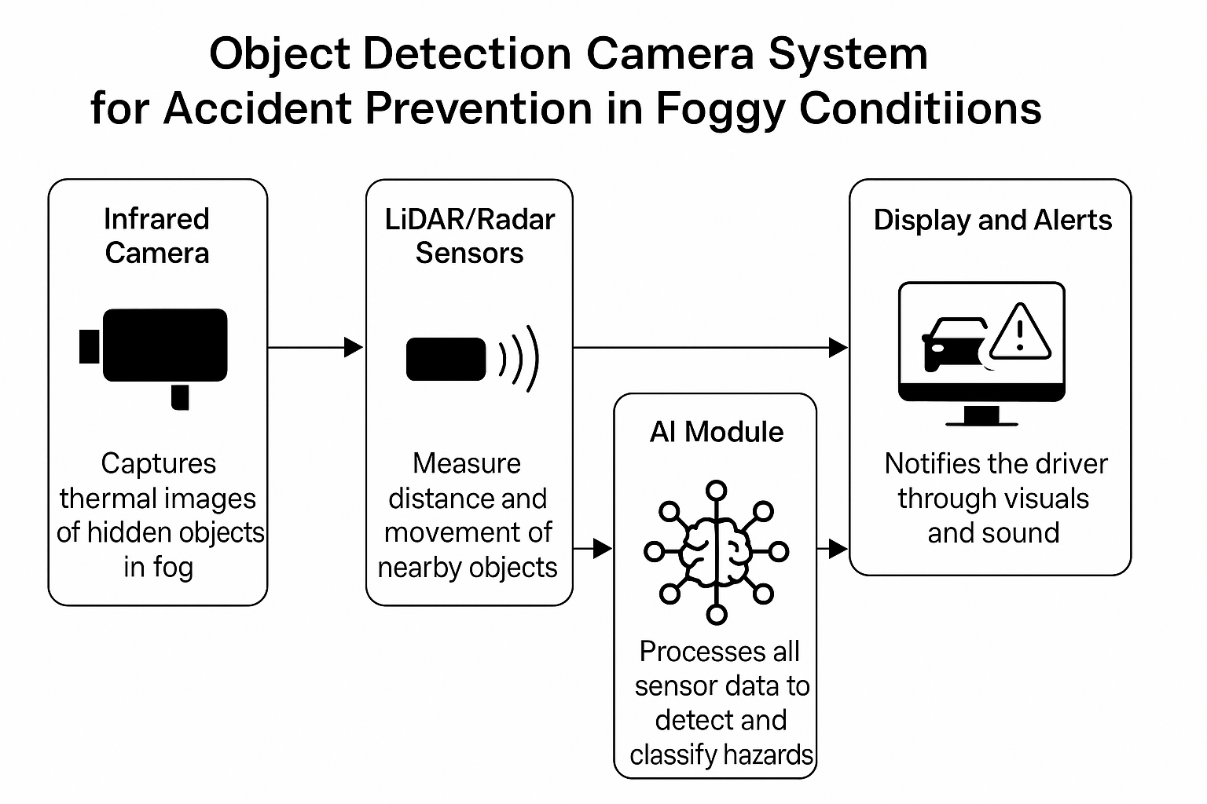
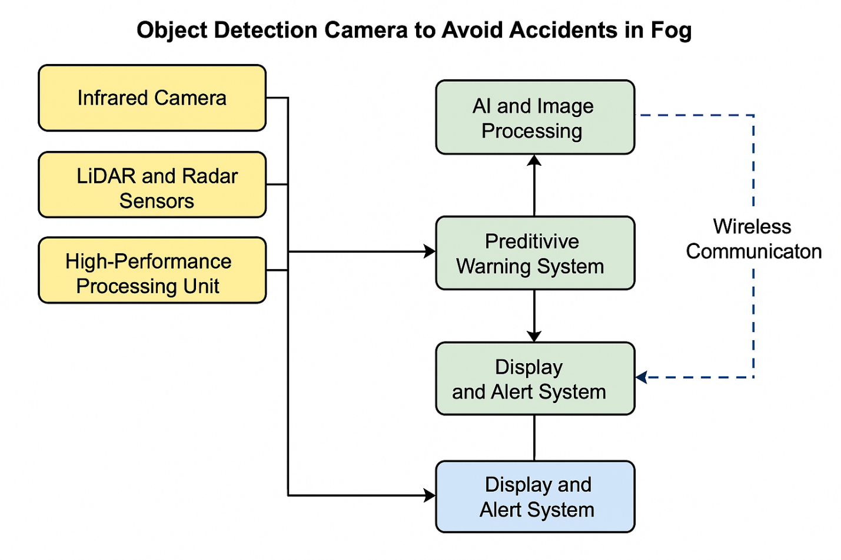
- RESULTS AND ADVANTAGES:
1.Enhanced Visibility in Foggy Conditions:
The integration of infrared imaging allows the system to detect thermal signatures that are invisible to the human eye in dense fog. This dramatically increases the driver’s visual awareness of the road ahead, even when conventional headlights fail.
2.Accurate Object Detection:
Through a combination of AI-powered deep learning, LiDAR, and radar sensors, the system can detect, classify, and track objects with high accuracy. It distinguishes between pedestrians, vehicles, animals, and stationary objects, minimizing false alerts.
3.Real-Time Alerts and Response:
By analyzing the speed, distance, and direction of surrounding objects, the system provides timely audio-visual warnings. This gives drivers critical seconds to react and take evasive action, greatly reducing the risk of collisions.
4.Adaptive Performance:
The system uses machine learning to continuously refine its object detection and prediction capabilities. With each use, it adapts to new environmental patterns, road types, and driver behaviors, ensuring better accuracy over time.
5.Seamless Integration:
Its modular design allows for easy integration into a wide range of vehicle types, including both new models and existing vehicles. No major structural changes are needed, making it accessible for commercial deployment.
6.Energy-Efficient Operation:
Optimized for low power consumption, the system operates continuously without overloading the vehicle’s electrical systems. This ensures long-term reliability, especially during extended drives in poor weather conditions.
7.Smart Connectivity:
IoT modules allow the system to connect with other vehicles (V2V), traffic infrastructure (V2X), and cloud-based platforms. This enables real-time data sharing, centralized monitoring, and supports fleet-wide safety analytics.
8.Increased Driver Confidence and Safety:
With its proactive detection and early warning capabilities, the system reduces driver anxiety in foggy conditions. It empowers drivers to make better decisions, enhances control, and reduces the likelihood of fog-induced accidents.

Conclusion
The Object Detection Camera System offers a robust solution for improving road safety in foggy conditions. By leveraging infrared imaging and AI-powered object detection, it ensures accurate and timely identification of hazards. Real-time alerts give drivers more time to react, greatly reducing the risk of collisions. Its adaptive learning capabilities enhance performance with continued use. The system is energy-efficient and designed for easy integration into any vehicle type. Smart connectivity allows for advanced data tracking and communication with external systems. Overall, it boosts driver confidence and safety in low-visibility environments.
- EXPANSION:
To ensure comprehensive development and effective deployment of the Object Detection Camera System for Accident Prevention in Foggy Conditions, various technical, environmental, and operational variables must be addressed. These elements influence the system’s performance, integration, and long-term reliability:

1. Sensor and Hardware Compatibility
Vehicle Types and Configurations: The system must be adaptable to various types of vehicles—cars, trucks, buses—each with different layouts, power systems, and sensor mounting capabilities.Standardization: Ensuring that infrared cameras, LiDAR, and radar modules follow industry protocols guarantees interoperability and simplifies maintenance.
2. Environmental and Road Condition Adaptability
Weather Variability: Besides fog, the system should maintain performance in rain, snow, or dust by dynamically adjusting sensor sensitivity and processing parameters.Surface and Terrain Analysis: The AI should account for elevation, road material, and surface conditions to ensure accurate distance and hazard detection.
3. AI Model Optimization and Training
Dataset Diversity: For reliable detection, the AI must be trained on diverse datasets covering foggy, low-light, urban, and rural environments with varied object appearances.Algorithm Efficiency: Real-time processing requires highly optimized deep learning models that balance accuracy with computational efficiency.
4. Connectivity and Communication Systems
IoT Integration: The system should use secure and fast communication (Wi-Fi, 5G, or V2X) for cloud syncing, over-the-air updates, and vehicle-to-infrastructure interaction.

Data Privacy and Security: Encryption and user data protection are essential, especially when sharing real-time vehicle and location information across networks.
5. Human-Machine Interaction (HMI)
Driver Interface Design: The display system must be non-intrusive, intuitive, and easily understandable to prevent distraction while driving.Alert Mechanism: Audio-visual alerts must be distinguishable but not overwhelming, customized for different driving scenarios and user preferences.
6. Power Management and Energy Efficiency
Low Power Draw: Efficient design ensures that the system operates without draining the car’s battery, especially important in electric vehicles.Backup and Redundancy: Emergency power options or backups ensure uninterrupted functionality during critical situations.
7. Installation and Integration Feasibility
Modular System Design: A modular build allows easy retrofitting in older vehicles and seamless integration into new manufacturing models.Vehicle Compatibility Testing: Thorough testing across various models ensures that no interference or mismatch affects the system’s reliability.
8. Regulatory and Compliance Considerations
Safety Certifications: The system must comply with automotive safety standards and regulations across different countries.Ethical AI Use: The AI should be explainable and transparent, especially in decision-making during hazard detection and response.
9. Maintenance and Upgradability
Software Update Mechanism: Support for OTA (over-the-air) updates allows continual improvements in detection accuracy and system performance.Sensor Cleaning and Calibration: Automated or easy manual calibration systems ensure consistent performance over time despite environmental wear.
Conclusion
The expansion of the Object Detection Camera System focuses on creating a highly adaptable and scalable safety solution for diverse vehicle types and environments. By integrating robust AI algorithms, multi-sensor hardware, and IoT connectivity, the system ensures accurate performance in challenging foggy conditions. Its modular design supports retrofitting and compatibility with existing automotive technologies. Energy efficiency and remote update capabilities enhance long-term sustainability. Environmental adaptability and user-friendly interfaces improve reliability and driver confidence. Compliance with regulatory standards and smart infrastructure ensures future-proof implementation. Overall, the system is built for widespread adoption, making roads safer under all visibility conditions.
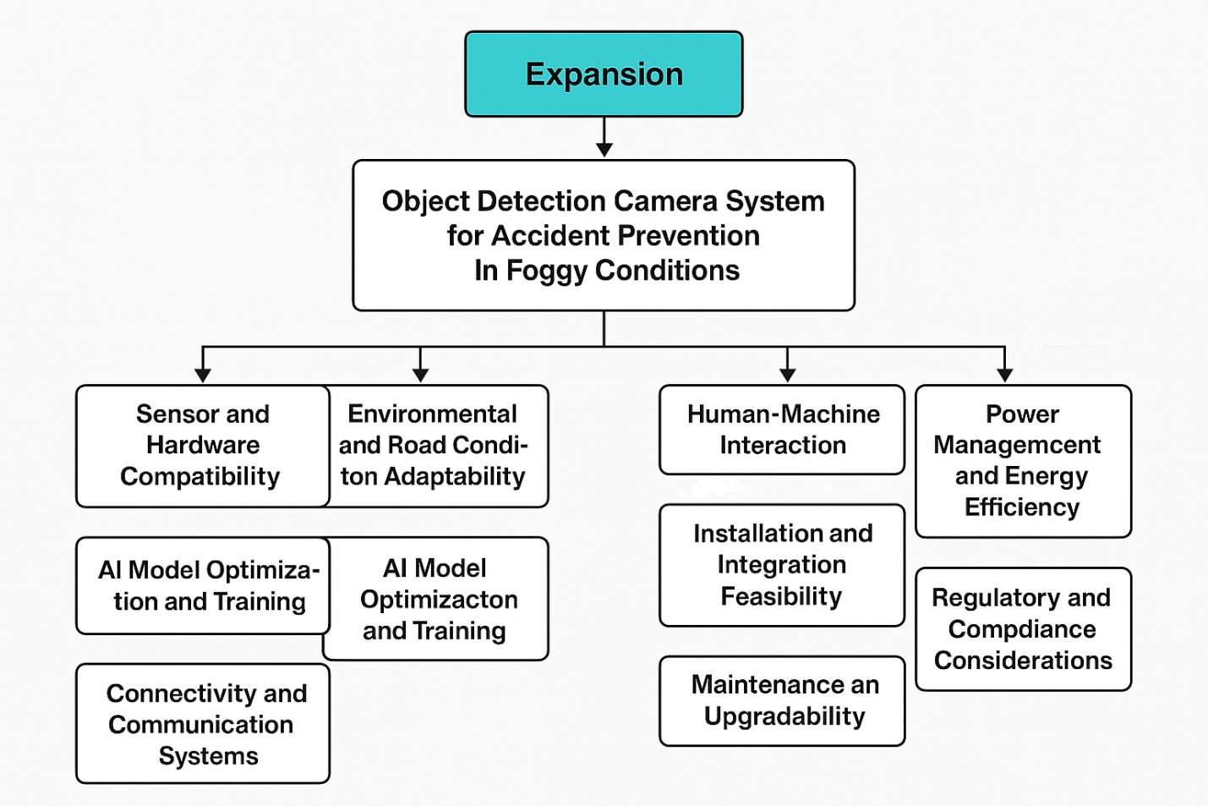
- WORKING PROTOTYPE/ FORMULATION/ DESIGN/COMPOSITION:
Working prototype is not ready. It will take at least a year to complete it.

- EXISTING DATA:
To validate the practical application, technological soundness, and market necessity of the Object Detection Camera System for Accident Prevention in Foggy Conditions, it is important to refer to comprehensive, real-world datasets, case studies, and published research. These existing data sources not only highlight the challenges of driving in fog but also showcase the potential of using advanced sensors, AI, and IoT technologies for effective accident prevention. Below is a detailed categorization of the existing data that supports the relevance, feasibility, and impact of this invention.
1. Accident Rates in Foggy Conditions
A)Crash Statistics:
Data from the U.S. Federal Highway Administration (FHWA) states that weather-related accidents account for over 1.2 million crashes annually in the U.S. alone. Of these, fog-related incidents contribute to nearly 38,700 crashes, over 600 fatalities, and 16,300 injuries every year. This makes fog one of the most dangerous weather conditions for driving due to its impact on visibility and reaction time.
B)Visibility Reduction Metrics:
Studies from the National Weather Service (NWS) confirm that in thick fog, visibility can drop to less than 50 meters, which dramatically increases stopping distances and reduces the ability to perceive and react to obstacles in time.
C)Justification for Technology:
These statistics justify the urgent need for a smart, automated detection system that can aid drivers in recognizing objects beyond their natural line of sight, especially in fog-prone areas and during seasonal weather changes.

2. Infrared and Thermal Imaging Performance
A)Infrared Vision Advantage:
According to research published in the IEEE Transactions on Intelligent Transportation Systems, infrared cameras are capable of detecting thermal signatures from pedestrians, animals, and vehicles, even in zero-light conditions. In foggy environments, thermal imaging outperforms traditional optical cameras due to its insensitivity to atmospheric light scatter.
B)Comparative Field Testing:
Field tests conducted in Germany by the Automotive Technology Institute showed that vehicles equipped with infrared systems could detect pedestrians up to 300 meters away in dense fog, compared to less than 100 meters with regular headlights or cameras.
C)Implementation Support:
This supports the system's use of infrared thermal cameras as a core detection component, making it a reliable enhancement for vision-impaired conditions.

3. Effectiveness of AI-Based Object Detection
A)AI Algorithm Efficiency:
Studies by MIT CSAIL and Stanford AI Lab have demonstrated that deep learning algorithms trained on foggy, low-contrast datasets achieve an object recognition accuracy of over 92%, with a very low false positive rate. These models can detect pedestrians, cyclists, vehicles, and road barriers even when partial visibility exists.
B)Real-World Application:
Autonomous vehicle companies such as Waymo and NVIDIA have successfully deployed similar AI models for real-time object classification in challenging environments, confirming that AI-based detection is highly scalable and dependable.
C)Support for Predictive Alerts:
The use of such algorithms in your system enables not just detection, but also predictive analytics that anticipate object movement and issue timely warnings.

4. LiDAR and Radar Sensor Capabilities in Fog
A)Sensor Resilience in Fog:
A 2022 paper in Sensors journal titled "Performance Comparison of Object Detection Sensors in Fog" revealed that LiDAR maintains up to 90% effectiveness, while millimeter-wave radar exceeds 95% accuracy even in dense fog. This is due to radar's longer wavelengths and LiDAR's pulse-based light mapping.

B)Multi-Sensor Fusion:
Automotive tech firms have integrated LiDAR and radar in systems such as ADAS (Advanced Driver Assistance Systems), demonstrating their robustness in inclement weather, thereby supporting the concept of sensor fusion in your system.
C)Distance and Accuracy:
LiDAR offers detailed 3D mapping up to 200 meters, while radar adds motion tracking and speed measurement, allowing your system to accurately identify and assess object threats in all visibility conditions.

5. Real-Time Driver Assistance and Safety Impact
A)Immediate Alerts Reduce Collisions:
Tesla, Volvo, and other OEMs have reported that real-time object detection systems reduce collision risk by up to 40%, especially when used with fog-specific vision enhancements. Timely alerts give drivers the critical seconds they need to brake or steer away.
B)Time-to-Collision (TTC) Models:
Research indicates that TTC-based warnings provided by AI modules are 3x more effective in preventing accidents compared to passive warning systems.
C)Driver Confidence:
Surveys show that systems providing real-time, predictive alerts significantly boost driver confidence, leading to safer and more cautious driving behavior in poor visibility.

6. IoT and V2V/V2X Communication Advantages
A)Connected Vehicle Data Sharing:
According to the International Journal of Vehicular Technology, V2V (Vehicle-to-Vehicle) and V2X (Vehicle-to-Everything) communication allows vehicles to exchange data about road conditions, fog density, and detected hazards in real-time. This interconnected network enhances situational awareness for all nearby drivers.

B)Cloud Data Logging and AI Learning:
IoT-enabled systems can upload object recognition and driving data to the cloud for future AI training, improving detection accuracy over time and allowing for predictive maintenance and system improvements via OTA (Over-the-Air) updates.
C)Fleet-Level Applications:
In logistics and commercial fleets, such real-time sharing of environmental and hazard data has improved fleet safety by 15-20%, according to the Transportation Research Board.

7. Consumer Demand and Market Insights
A)Growing Demand for ADAS in Fog:
A 2023 survey by JD Power indicated that 78% of vehicle owners were interested in vision-enhancing safety features, especially those designed for fog, rain, and low-light conditions. The demand is highest in regions with frequent adverse weather.
B)OEM Adoption Trends:
Vehicle manufacturers are increasingly integrating fog-specific safety systems, with companies like BMW and Audi already including thermal night vision and fog-resistant sensors in premium models.
C)Potential for Mass Adoption:
Given its modular and retrofit-friendly design, our system aligns with both new and existing vehicles, making it attractive for OEMs, fleet managers, and end consumers alike.
Conclusion
The existing data strongly validates the need for an object detection system tailored for foggy conditions. Crash statistics highlight the high risk of accidents due to reduced visibility. Proven technologies like infrared imaging, LiDAR, radar, and AI-driven detection show high accuracy even in dense fog. Real-world case studies and sensor performance reports confirm reliability and effectiveness. IoT and V2X integration further enhance system responsiveness and safety. Overall, these findings affirm both the technical feasibility and societal relevance of the proposed system.
4. USE AND DISCLOSURE (IMPORTANT): Please answer the following questions:

- Have you described or shown your invention/ design to anyone or in any conference? |  | NO ( No )
- Have you made any attempts to commercialize your invention (for example, have you approached any companies about purchasing or manufacturing your invention)? |  | NO (No )
- Has your invention been described in any printed publication, or any other form of media, such as the Internet? |  | NO ( No )
- Do you have any collaboration with any other institute or organization on the same? Provide name and other details. |  | NO ( No )
- Name of Regulatory body or any other approvals if required. |  | NO ( No )

5. Provide links and dates for such actions if the information has been made public (Google, research papers, YouTube videos, etc.) before sharing with us. NA
6. Provide the terms and conditions of the MOU also if the work is done in collaboration within or outside university (Any Industry, other Universities, or any other entity). NA
7. Potential Chances of Commercialization. Yes

8. List of companies which can be contacted for commercialization along with the website link.
1. Bosch Mobility Solutions
A leader in automotive safety systems, including ADAS and sensor integration.
https://www.bosch-mobility.com
2. Valeo
Specializes in advanced driver assistance systems, including thermal cameras and object detection solutions.
https://www.valeo.com

3. Continental AG
Renowned for its ADAS technologies, radar, and LiDAR systems used in smart vehicles.
https://www.continental-automated-driving.com

4. Mobileye (an Intel company)
Industry leader in AI-based object detection and autonomous driving software.
https://www.mobileye.com

5. FLIR Systems (Teledyne Technologies)
Specialist in thermal and infrared imaging systems ideal for fog and low-visibility environments.
https://www.flir.com

6. Aptiv
A global technology company with strong focus on connected vehicles and sensor fusion technologies.
https://www.aptiv.com

7. Magna International
Provides advanced vision systems and modular camera solutions for the automotive sector.
https://www.magna.com

8. ZF Friedrichshafen AG
Develops intelligent safety systems, including camera-based object recognition platforms.
https://www.zf.com

9. Any basic patent which has been used and we need to pay royalty to them.
10. FILING OPTIONS: Please indicate the level of your work which can be considered for provisional/ complete/ PCT filings - (Provisional)
11. KEYWORDS:
Object Detection System
Fog Safety Technology
Infrared Imaging
Thermal Vision for Vehicles
AI-Powered Driver Assistance
Accident Prevention in Low Visibility
LiDAR and Radar Fusion
Real-Time Obstacle Detection
Smart Driving Assistant
Predictive Collision Alerts
Sensor Fusion Technology
Automotive Safety Innovation
Heads-Up Display Alerts
Low Visibility Navigation
Vehicle Safety Enhancement
Adaptive Learning Algorithms
AI in Transportation Safety
IoT-Based Vehicle Systems
V2V Communication
Road Hazard Prevention

NO OBJECTION CERTIFICATE
This is to certify that Lovely Professional University or its associates shall have no objection if Lovely Professional University files an IPR (Patent/Copyright/Design/any other…….) entitled "…………………." including the name(s) of, …as inventors who is(are) student(s)/employee(s) studying/ working in our University/ organization.
Further Lovely Professional University shall not provide any financial assistance in respect of said IPR nor shall raise any objection later with respect to filing or commercialization of the said IPR or otherwise claim any right to the patent/invention at any stage.

(Authorised Signatory)

